Assignment 1 :  
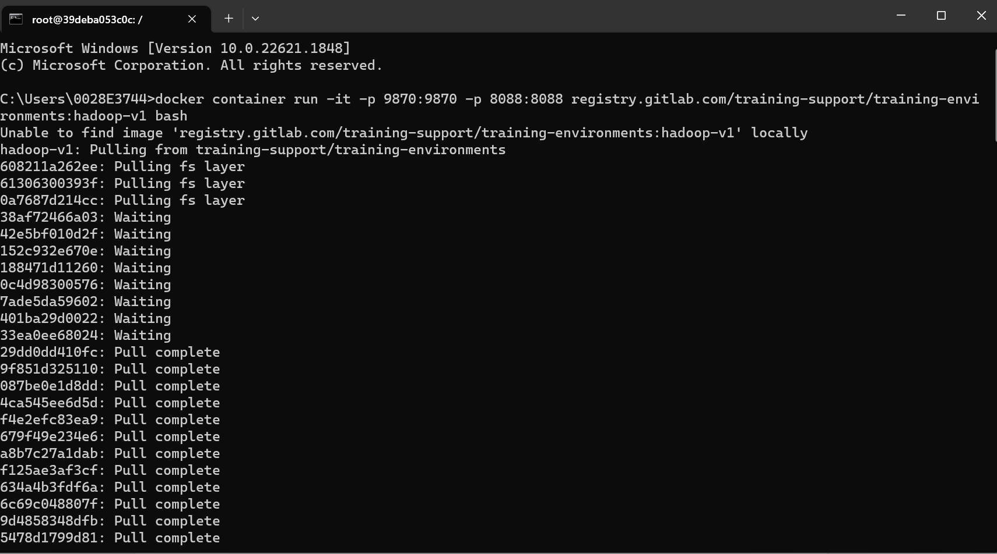

Assignment 2:

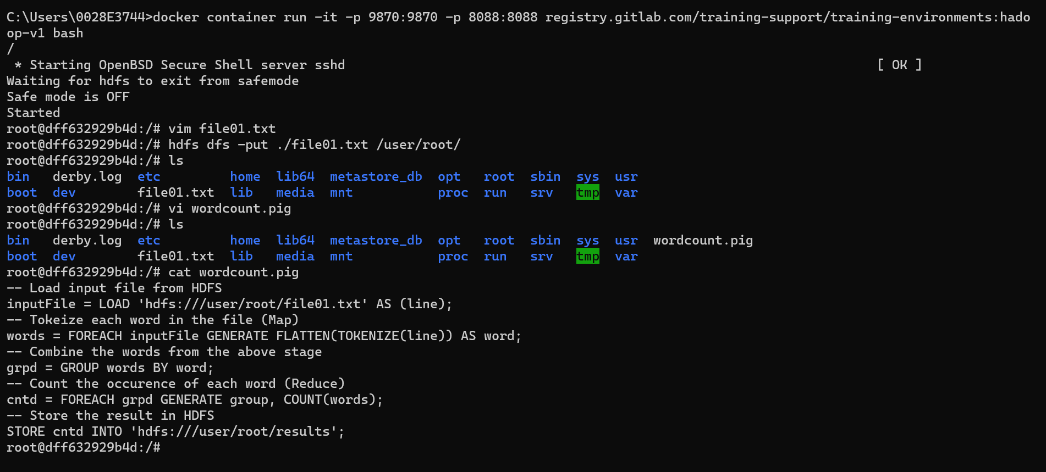  
  
Assignment 3:

